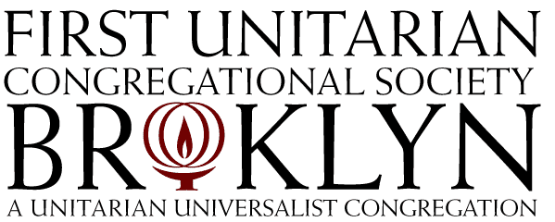

48 Monroe Place, Brooklyn, New York 11201-2603
phone: (718) 624-5466 fax:(718) 797-2916 website: www.fuub.org
e-mail: office@fuub.org
Accessibility Program: Phase I

Yes! I/we support the First UU Accessibility Program, to improve the physical accessibility of our facilities and to enable full participation in Congregational life by all persons. I/we pledge $_________ to support Phase I of the Accessibility Program, which was approved by the Congregation at the Annual Meeting on May 19. The improvements in Phase I are expected to be completed by September. I/we wish to pay my/our pledge approximately as follows:

May _________ August ________ November ________
June _________ September ________ December ________
July _________ October ________

Address

City State Zip Code

Home Telephone Cell Phone(s)____

E-mail Address(es) ______ _________________________________

❒ I plan to pay by credit card or stock and will contact the Director of Congregational Services. (To make arrangements, call 718-624-5466 or email dcs@fuub.org.)

Signature Date

Signature Date

Have you included First Unitarian in your estate planning?
For Office Use Only:
Checked by____________________

ACS _________________________
___ Yes, I have. ___No, not yet

Important Information about Your Pledge

All gifts are received with gratitude. Our mission to support each other’s participation in Congregational life is only possible through the generosity of our members and friends.
Your pledge to our Congregation is a promise, but we understand that circumstances change. If you are unable to complete your pledge, we ask that you contact the Director of Congregational Services or one of our ministers.
If you prefer to pay your pledge with stock options or by credit card, please contact the Director of Congregational Services to make arrangements.
Your pledge is fully tax deductable as allowed by law.
Pledge payments can be mailed to the office or dropped in the Sunday plate. Checks should be made out to First Unitarian Congregational Society, with “Accessibility” in the memo field.
If you pay by cash, please enclose it in an envelope marked with your name(s), the amount and the note “Accessibility”.
If total contributions to Phase I of the Accessibility Program exceed the final costs, the remainder will be applied toward the costs of Phase II.
Important Contact Information:
Rob Petrillo, Director of Congregational Services, 718-624-5466 X108, dcs@fuub.org
Rev. Ana Levy-Lyons, Senior Minister, 718-624-5466 X107
Address: First Unitarian Congregational Society, 48 Monroe Place, Brooklyn, NY 11201

