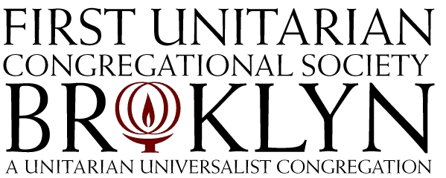
Annual Meeting, May 17, 2015

Agenda

Topic Presenter
Call to Order Christine Lloyd, Clerk
Election of Moderator Christine Lloyd, Clerk
Opening of Meeting and Review of Agenda Moderator
Opening Words Rev. Ana Levy-Lyons
Report of the Senior Minister Rev. Ana Levy-Lyons
Report of the Director of Education Ministries Meagan Henry
Lifecycle Events Rev. Ana Levy-Lyons
Report of the Director of Congregational Life Garnett Losak
Review of Meeting Rules Moderator
Appointment of Parliamentarian & Timekeeper Moderator
Reading of Behavioral Covenant Moderator and Congregation
Election of Inspectors of Elections Moderator and Congregation
Report of the Nominating Committee Koren Manning
- Election of Officers Congregation
Report of the Deacons Seth Faison
- Election of Deacon Congregation
Report on Investment Policy Devin Judge-Lord
- Motion, Discussion, and Vote Congregation
Report of Forward Team Lee Pardee
- Motion, Discussion and Vote Congregation
Report of Inspectors of Elections Inspectors of Elections
Presentation of Budget Tom Check, Mitch Major
- Motion, Discussion, and Vote Congregation
Adjournment Moderator

