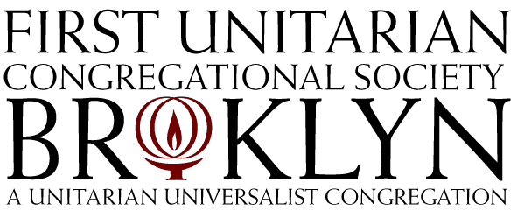

48 Monroe Place

Brooklyn, New York 11201
phone: (718) 624-5466
www.fuub.org
Giving Sanctuary
Fiscal Year 18-19 Generosity Campaign Pledge Form
The First Unitarian Congregational Society in Brooklyn is a joyful, loving, religious community that inspires and empowers people to Grow spiritually, Care for one another, and Work for social justice and stewardship of the earth.

If your current year pledge is: Your suggested FY18-19 pledge is:
Less than $1,000 Endeavor to move to that level.
$1,000 to less than $3,000 $3,000 or more. This is the amount needed to sustain our congregation.
$3,000 or more You are a sustaining donor! Thank you. Consider moving to the next thousand.
This is my/our first pledge Please give to best of your ability.
These recommended pledge levels are meant as guidelines to help us fully fund our wonderful programs and important mission. We realize that not everyone can give at sustaining levels. All gifts, no matter the size, are received with much gratitude.

My/Our Fiscal Year 2018/2019 Pledge: $_____________(due by June 30, 2019)

Names of all household members over 16 years of age who are covered by this commitment:
Name Phone: Email
Name Phone: Email
Name Phone: Email
Name Phone: Email
Address City State Zip
__________________________________________________________________________________________________________
Signature Date ___
Signature Date ___
Canvasser Date ___
For Office Use Only:
Checked by____________________

SK Entry_______________________
Yes! I have included FUUB in my estate planning.
Please have someone contact me regarding planned giving to FUUB.

Important Information about Your Pledge

Pledges of any size are received with gratitude. Our mission is to support each other’s spiritual journeys and to work for justice in our community. This is only possible through the generosity of our members and friends. On behalf of the First Unitarian Congregational Society, thank you.

Fiscal Year 2017-2018 Pledge Facts
(As of January 2018)

Total Pledged: $312,000
Median Pledge: $1,000
Most common Pledge $1,200
Average Pledge: $1,600
Number of Pledging Households: 203
Sustaining Pledge Level: $3,000

Our by-laws require a financial pledge and payment on that pledge to maintain voting membership in the congregation. If making a financial donation would constitute a financial hardship, please contact Rev. Ana to request a waiver so that you can maintain your full voting membership. But please keep in mind that even a small annual pledge is adequate to maintain voting membership.
Paying Your Pledge
Many donors find making monthly pledge payments is easiest by using online bill pay. You may also use our on-line payment option. You can use a credit card (please consider adding 2.75% to cover bank charges) or make a bank account transfer. See the link on our website www.fuub.org. Pledge payments made by personal check can be mailed to the office or dropped in the Sunday plate. We now have Give by Text (see instructions). Checks should be made out to First Unitarian.
IMPORTANT: So that we can properly account for all pledge payments, please mark all checks with “pledge 18-19” in the memo line. We do not recommend that you make payments with cash. However, if you do, enclose cash in a sealed envelope marked with your name(s), the amount enclosed, and the note “pledge 18-19.”

Your pledge to our congregation is a promise. We understand that circumstances change. If you are unable to complete your pledge, we ask that you contact our Office Manager, Wendy Russell, Garnett Losak, or Rev. Ana as soon as possible.
Pledge statements are mailed semi-annually. Your pledge payment is tax deductible to the extent allowed by law. However, the church is on a July-June fiscal year so your year-end contribution statement will reflect only those pledge payments made in the calendar tax year. This means that depending on when your payments are made, your fiscal year pledge may be split between two tax years.

Important Contact Information:
Wendy Russell, Office Manager, (718) 624-5466 X108, office@fuub.org
Garnett Losak, Director of Congregational Life, (646) 456-4027, garnett@fuub.org
Rev. Ana Levy-Lyons, Senior Minister, (718) 624-5466, ana@fuub.org
Meagan Henry, Director of Religious Education, (718) 624-5466, meagan@fuub.org

